UNIT II

AC CIRCUITS

GENERATION OF ALTERNATING VOLTAGES & CURRENTS

Alternating voltages may be generated by rotating a coil in a magnetic field & by rotating a magnetic field within a stationary coil.

The value of the voltage generated depends, in each coil, upon the no of turns on the coil, strength of the field & the speed at which the coil or magnetic field rotates.

Equations of alternating voltages & Currents:

E (t) = Em sinθ = Em sin ( 2𝜋)t

𝑇

I = Im sin 2𝜋𝑓𝑡 = Im sin ( 2𝜋)

𝑇

T = time – period of alternating voltage or Current = 1/f

∴ Induced emf varies as sine function of the time angle wt & when emf is plotted against time, a curve simulated below is obtained.

Thus curve varies in this manner is known as sinusoidal.

Terms used for periodic functions

1. **Alternating quantity: -** It is one which is changing w.r.t time e.g., V(t) , i(t), p(t)

It is period i.e. its variation repeats with certain periodicity.

Direct current quantity:

It is constant and is not changing w.r.t time e.g., V,I

1. Wave form or wave shape:

The graphical representation of the variation of ac quantity w.r.t to time



1. **Cycle:** One complete set of variations of an alternating quantity.
2. **Time period (T):** It is the time taken for completing one cycle. It is expressed in
3. seconds (or) radius.
4. **Frequency (f):** The number of cycles completed in one second is called frequency & it is expressed in cycles/second or Hertz.

f = 1

𝑇

or T = 1

𝑓

1 cycle = 2∏ radians, T sec = 2∏ radians

1. **Angular velocity:** Angular traced at in one second is called angular velocity ω

2∏ = 2∏f (θ = ωt at t = 1 then θ = **ω)**

𝑇

1. **Amplitude:** The maximum value of alternating quantity is called an amplitude.

Root mean square value:

The R.M.S. value of an alternating current is given by that steady (dc) current which when flowing through a given circuit for a given time produces the same heat as produced by the alternating current when flowing through the same circuit for the same time. It is also known as the effective or virtual value of th4e alternating current.

For computing the R.M.S. value, of symmetrical sinusoidal alternating currents, either mid-ordinate method or analytical method may be used, although for symmetrical but non – sinusoidal wires, the mid ordinate method would be found more convenient.

Analytical method:

The standard form of a sinusoidal alternating current is I = Im sin **ωt = Im sin**θ.

The mean of the squares of the instantaneous values of current over one complete cycle is (even the value over half a cycle will do).

= 2 2𝑑𝜃

∫

0 2𝜋−0

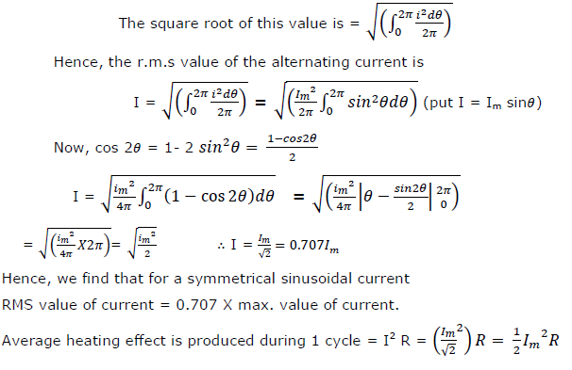

RMS value of a complex wave:

In case of complex wave also either mid – ordinate method (when equation of the wave is not known) or analytical method ( when equation of the wave is known )

Let a current equation be given by

I =12sin ωt +6 sin (3 ωt – 9/6 ) + 4∫ (125ωt + π) flow through a resistor of R ohm.

3

Then, in the time period T second of the wave, the effect due to each component is as below

Fundamental – ( 12)2 𝑅𝑇 𝑤𝑎𝑡𝑡𝑠

√2

3rd harmonic - ( 6 )2 𝑅𝑇 𝑤𝑎𝑡𝑡𝑠

√2

5th harmonic - ( 4 )2 𝑅𝑇 𝑤𝑎𝑡𝑡𝑠

√2

∴ Total heating effect of the complex wave, then equivalent heating effect is I2RT

I2RT = RT[(12)2 + ( 6 )2 + ( 4 )2]

√2 √2 √2

If I is the rms value of complex wave, then equivalent heating effect is I2RT.

I2RT = RT[(12)2 + ( 6 )2 + ( 4 )2]

√2 √2 √2



If a direct current of 5 amp flowing of flowing in the circuit also, then the rms value would have been



∴ For a complex wave --- the rms value of a complex current wave is equal to the square root of the sine of the squares of the rms value of its individual components.

# Calculate the rms value, form factor & of a periodic voltage having the following values for equal time intervals changing suddenly from one value to next – 0, 5, 10, 20, 50, 60, 50, 20, 10, 5, -10 -20 -50-20-10-5-0

VRMS

= 02+52+102+202+502+602+502+202+102+52

10

= √965 = 31𝑉

VAV = 0+5+10+20+50+60+50+20+10+5 = 23𝑉

10

FF = RMS value

Average value

= 31 = 1.35

23

Average value:

The average value Ia of an alternating current is expressed by that steady current which transforms across any circuit the same change as is transformed by that alternating current during the same time.

Hence, in their case, the average value is obtained by adding or integrating the instantaneous values of current over one half – cycle.

* 1. Mid – ordinate method

IAV

= 𝑖1+𝑖2+𝑖3+4…+𝑖𝑛

𝑛

This method may be used for sinusoidal & non – sinusoidal waves.

* 1. Analytical method

The standard equation of an alternating current, I = Im sin𝜃

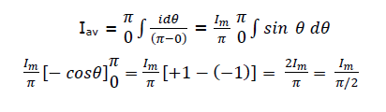

Twice the maximum current π

Iav

= 𝐼𝑚 1/2𝜋

= 0.637 𝐼𝑚

[RMS value is always given than average value except in the case of a rectangular wave when both are equal]

Form factor:

𝑟𝑚𝑠 𝑣𝑎𝑙𝑢𝑒

Kf =

𝑎𝑣𝑒𝑟𝑎𝑔𝑒 𝑣𝑎𝑙𝑢𝑒

= 0.707 𝐼𝑚 = 1.1

0.637 𝐼𝑚

Crest or peak or Amplitude factor:

It is defined as the ratio Ka = maximum value

rms value

= Im Im/√2

=√2 = 1.414(for sinusoidal a.c.

only)

For sinusoidal alternating voltage also Ka = Em = 1.414

Em/√2

Knowledge of this factor is of importance in dielectric insulation testing, because the dielectric stress to which the insulation is subjected, is proportional to the maximum or

peak value of the applied voltage. The knowledge is also necessary when measuring iron losses, because the iron loss depends on the value of maximum flux.

Single phase AC circuits:

In dc circuits, voltage applied & current flowing are constant w.r.t time & to the solution to pure dc circuits can be analyzed simply by applying ohm`s law.

In ac circuits, voltage applied and currents flowing change from instant to instant.

If a single coil is rotated in a uniform magnetic field, the currents thus induces are called single phase currents.

A.C. Through pure Ohmic resistance only:

The circuit is shown in Fig Let the applied voltage be given by the equation.

V = Vm 𝑠𝑖𝑛𝜃 = 𝑉𝑚𝑠𝑖𝑛𝜔𝑡

Let R = Ohmic resistance; I = instantaneous current.

Obviously, the applied voltage has to supply Ohmic voltage drop only. Hence for equilibrium

V = iR (i)

Putting the value of V from above, we get 𝑉𝑚

𝑠𝑖𝑛𝜔 = 𝑖𝑅; 𝑖 = 𝑉𝑚 𝑠𝑖𝑛𝜔𝑡 ( ii)

𝑅

Current `i` is maximum when sin𝜔𝑡 is unity

∴ Im = Vm/R

Hence, equation (ii) becomes, I = Im sin 𝜔𝑡

Comparing (i) And (ii), we find that the alternating voltage and current are in phase with each other as shown in fig. It is also shown vectorially by vectors VR and I in fig

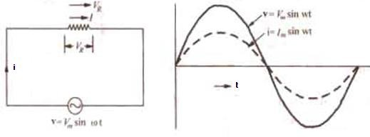

**Power.** Instantaneous power, P = Vi = 𝑉𝑚𝐼𝑚 - 𝑉 𝑚𝐼𝑚 𝑐𝑜𝑠 2𝜔𝑡

2 2

Power consists of a constant part 𝑉𝑚𝐼𝑚

2

and a fluctuating part  𝑉𝑚𝐼𝑚 𝑐𝑜𝑠 2𝜔𝑡 of frequency

2

double that of voltage and current waves. For a complete cycle the average of

𝑉𝑚𝐼𝑚 𝑐𝑜𝑠 2𝜔𝑡 is zero

2

Hence, power for the whole cycle is



P = VI Watts

Where V = rms value of applied voltage. I = rms value of the current.

It is seen from the fig that no part of the power cycle becomes negative at any time. In other words, in a purely resistive circuit, power is never zero. This is so because the instantaneous values of voltage and current are always either both positive and negative and hence the product is always positive.

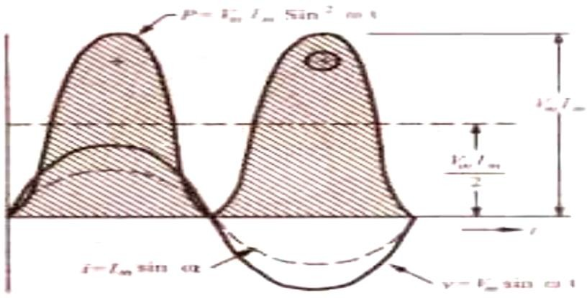

A.C. Through Pure Inductance Alone:

Whenever an alternating voltage is applied to a purely inductive coil, a back e.m.f. is produced due to the self-inductance of the coil. As there is no Ohmic voltage drop, the applied voltage has to overcome this self – induced e.m.f. Only. So at every step

V =L 𝑑𝑖

𝑑𝑡

Now V = 𝑉𝑚𝑠𝑖𝑛𝜔𝑡

#### 𝑉𝑚

𝑠𝑖𝑛𝜔𝑡 = 𝐿 𝑑𝑖

𝑑𝑡

#### ∴ 𝑑𝑖 = 𝑉𝑚 𝑠𝑖𝑛𝜔𝑡 𝑑𝑡

𝐿

Integrating both sides we get, I = 𝑉𝑚 ∫ 𝑠𝑖𝑛𝜔𝑡 𝑑𝑡

𝐿

𝑉 (− cos 𝜔𝑡)

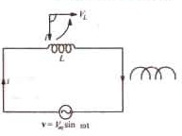𝜔𝐿

𝑉𝑚 (sin 𝜔𝑡 − 𝜋) = 𝑚 (sin 𝜔𝑡 𝜋)

𝜔𝐿

2 𝑋𝐿 2

Max value of I is 𝐼 = 𝑉𝑚 when 𝑠𝑖𝑛 (𝜔 - 𝜋) 𝑖𝑠 𝑢𝑛𝑖𝑡𝑦

𝑚 𝜔𝐿 2

Hence, the equation of the current becomes **I =** 𝐼𝑚

𝑠𝑖𝑛 (𝜔𝑡 – 𝜋 )

2

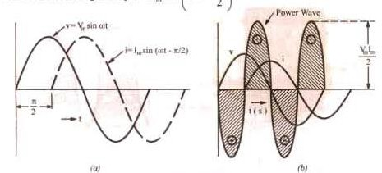

Clearly, the current lags behind the applied voltage by a quarter cycle (fig) or the

phase deference between the two is 𝜋

2

with voltage leading. Vectors are shown in fig.

where voltage has been taken along the reference axis. We have seen that

Im = 𝑉 = 𝑉𝑚.

𝜔𝐿 𝑋𝐿

Here 𝜔𝐿 plays the part of `resistance`. It is called the (inductive) reactance XL of the coil and is given in ohms if L is in Henry and 𝜔 is in radians/second.

Now, XL = 𝜔𝐿 = 2𝜋𝑓𝑙 𝑜ℎ𝑚. It is seen that XL depends directly on frequency of the voltage Higher the value of f, greater the reactance offered and vice-versa.

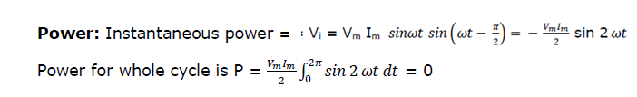

It is also clear from fig that th e average demand of power from the supply for a complex cycle is zero. Here again it is seen that power wave is a sine wave of frequency double that of the voltage and current waves. The maximum value of the instantaneous

power is 𝑉𝑚𝐼𝑚

2

A.C. Through pure capacitance alone :

When an alternating voltage is applied to the plates of a capacitor, the capacitor is charged first in one direction and then in the opposite direction. When reference to fig.

V = p.d. developed between plates at any instant. q = Charge on plates at that instant.

Then q = cv (where C is the capacitance)

q= C Vm sin 𝜔𝑡. putting the value of v

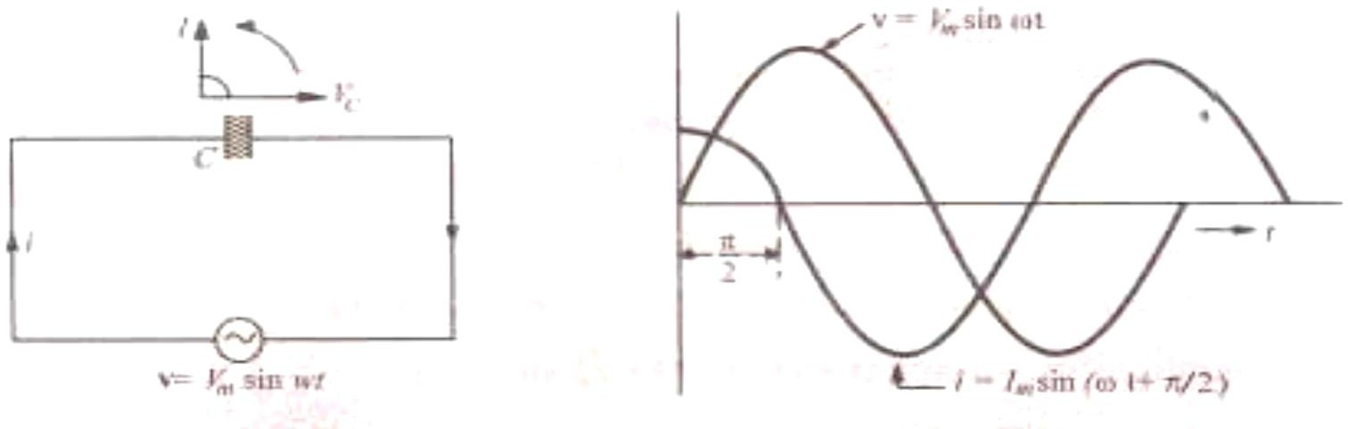

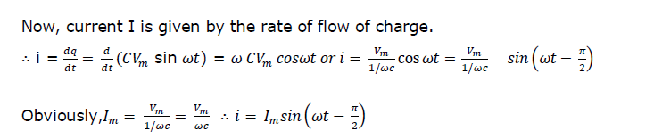

The denominator Xc = 1/𝜔𝐶 is known as capacitive reactance and is in ohms if C is in farad and 𝜔 in radian/second. It is seen that if the applied voltage is given by V =

Vm sin 𝜔𝑡, then the current is given by I = Im sin (𝜔𝑡 + 𝜋).

2

Hence we find that the current in a pure capacitor leads its voltage by a quarter

cycle as shown in fig. or phase difference between its voltage and current is 𝜋

2

with the

current leading. Vector representation is given in fig. Note that Vc is taken along the reference axis.

**Power** Instantaneous power

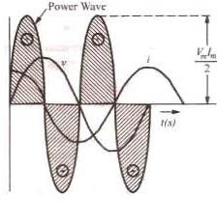

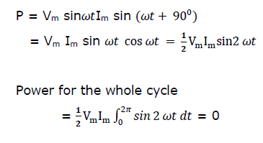

This fact is graphically illustrated in fig. we find that in a purely capacitive circuit. the average demand of power from supply is zero ( as in a purely inductive circuit). Again, it is seen that power wave is a sine wave of frequency double that of the voltage

and current waves. The maximum value of the instantaneous power is VmIm.

2

A.C. Through Resistance and inductance:

A pure resistance R and a pure inductive coil of inductance L are shown connected in series in fig.

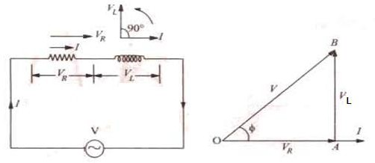

Let V = r.m.s. value of the applied Voltage, I = r.m.s. value of the resultant current VR = IR – Voltage drop across R ( in phase with I), VL = I.XL – voltage drop across coil (ahead of I by 900)

These voltage drops are shown in voltage triangle OAB in fig. Vector OA represents Ohmic drop VR and AB represents inductive drop VL. The applied V is the vector sum of the two i.e. OB

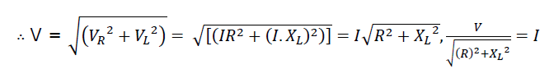

The quantity √𝑅2 + 𝑋𝐿 2, is known as the impedance (Z) of the circuit. As seen from the

Impedance triangle ABC (fig,) Z2 = 𝑅2 + 𝑋𝐿 2

i.e (impedance)2 = (resistance)2 + (Reactance)2

From fig. it is clear that the applied voltage V leads the current I by an angle Ф such that

tanФ = 𝑉𝐿

= 𝐼 .𝑋𝐿 = 𝑋𝐿 = 𝜔𝐿

= 𝑟𝑒𝑎𝑐𝑡𝑎𝑛𝑐𝑒 ∴ ∅ = 𝑡𝑎𝑛−1 𝑋𝐿

𝑉𝑅

𝐼.𝑅 𝑅

𝑅 𝑟𝑒𝑎𝑐𝑡𝑎𝑛𝑐𝑒 𝑅

The same fact is illustrated graphically in fig.

In other words, current I lags behind the applied voltage V by an angle ∅. Hence, if applied voltage is given by v = Vm sin ωt, then current equation is

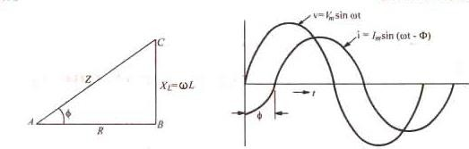i = Im sin (ωt - ∅) where Im = Vm/Z

IIn fig. I has been resolved in to its two mutually perpendicular components, I cos Ф along the applied voltage V and I sin Ф in quadrature (i.e. perpendicular) with V.

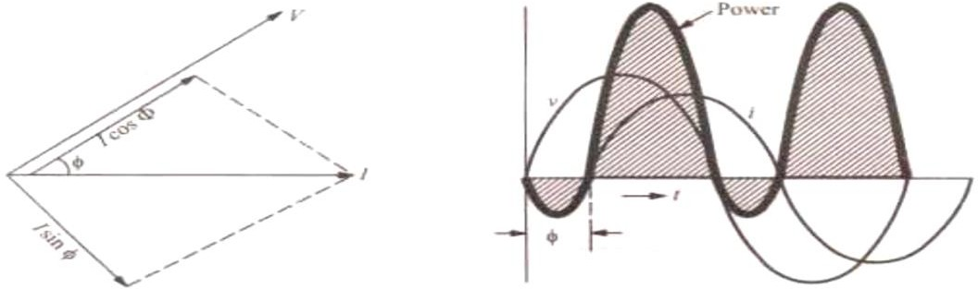

The mean power consumed by the circuit is given by the product of V and that component of the current I which is in phase with V

So P = V X I cos Ф = r.m.s. voltage X r.m.s. current X cos Ф The term cos Ф is called the power factor of the circuit

Remember that in an a.c. circuit, the product of r.m.s. amperes gives volt ampere (VA) and not true power in watts. True power (W) = volt amperes (VA) power factor.

Or Watts = VA cos Ф0 Or

It should be noted that power consumed is due to Ohmic resistance only because pure inductance does not consume any power.

Now P = VI cos Ф = VI X (R/Z) = V/Z X IR = I2R (∵ cos Ф = R/Z) or P = I2R watt. Graphical representation of the power consumed is shown in fig.

Let us calculate power in terms of instantaneous values.

Instantaneous power is = vi = vm sin ωt X Im sin (ωt – Ф ) = Vm Im sin ωt sin (ωt – Ф )



Obviously this consists of two parts

A constant part 1 𝑉 𝐼

of which contributes to real power

2 𝑚 𝑚

A pulsating component 1 𝑉 𝐼

cos(2ωt – Ф ) which has a frequency twice that of the

2 𝑚 𝑚

voltage and current. It does not contribute to actual power since its average value over a complete cycle is zero.

Hence, average power consumed1 𝑉 𝐼 𝑐𝑜𝑠Ф = Vm . Im cosФ = VI cosФ where V and I

represent rms values.

Symbolic notation

2 𝑚 𝑚

√2 √2



Impedance vector has numerical value of

Its phase angle with the reference axis is  It may also be expressed in the polar form as

1. Assuming

It shows that current vector is lagging behind the voltage vector by

The numerical value of current is

1. However, If we assume that

It shows that voltage vector is  a head of current vector is ccw direction as shown in fig.

**Power factor:** it may be defined as

1. Cosine of the angle of lead or lag

𝑅𝑒𝑠𝑖𝑠𝑡𝑎𝑛𝑐𝑒

1. The ratio R/Z =

𝐼𝑚𝑝𝑒𝑑𝑎𝑛𝑐𝑒

1. The ratio = True power

Apperent power

= Watts = W Volt−amp VA

Active and reactive components of circuit current I :

Active component is that which is in phase with the applied voltage V i.e Icos *Ф*. It is also known as ‘wattful’ component.

Reactive component is that which quadrature is with V i.e. ISin *Ф* it is also known as ‘watt less’ or ‘idle’ component.

It should be noted that the product of volts and amperes in an a.c. circuit gives volt-amperes (VA). Out of this, the actual power is VA cos *Ф* = W and reactive power is  expressing the values in KVA, we find that it has two regular components :

1. Active component which is obtained by multiplying KVA by and this gives power in KW.
2. The reactive component known as reactive KVA and is obtained by multiplying KVA by. It is written as KVAR (kilovar). The following relations can be easily deduced.



These relationships can be easily understood by referring to the KVA triangle of fig.13.10. where it should be noted that lagging KVAR has been taken as negative.

For example, suppose a circuit draws a current of 1000A at a voltage of 20,000 V and has a power factor of 0.8. Then



ACTIVE, REACTIVE AND APPARENT POWER

Let a series circuit draw a current of when an alternating voltage of r.m.s value V is applied to it. suppose that current lags behind the applied voltage by Ф. The three powers drawn by the circuit are as under:

1. **Apparent power(s):** It is given by the product of rms values of applied Voltage and circuit current.

S = VI = (IZ).I = I2Z volt-amperes (VA)

1. **Active power (P or W):** It is the power which is actually dissipated in the circuit resistance. P = I2R = VI cos Ф watts
2. **Reactive power (Q) :** It is t he power developed in the inductive reactance of the circuit.

Q = I2XL = I2.Z sin Ф = I . (IZ).sin Ф = VI sin Ф volt-amp reactive (VAR) These three powers are shown in the power triangle of fig. from where it can be seen that

S2 = P2 + Q2 or √ 𝑃2 + 𝑄2.

A.C. Through Resistance and capacitance:

This circuit is shown in fig. here VR = IR = drop across R in phase with I.

As capacitive reactance Xc is taken negative, Vc is shown along negative direction if Y- axis in the voltage triangle

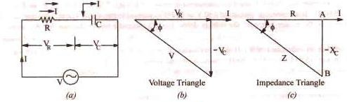



The denominator is called the impedance of the circuit. So Impedance triangle is shown in fig.

From fig. (b) it is found that I leads V by angle such that 

Hence, it means that if the equation of the applied alternating voltage is v = Vm sinωt, the equation of the resultant current in the T-C circuit is I = Im sin (ωt + Ф ) so that current leads the applied voltage by an angle . This fact is shown graphically in fig.

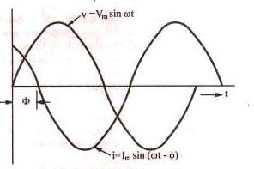

**Example:** An A.C. voltage (80+j 600 volts is applied to a circuit and the current flowing is (-4+j 10 ) amperes. Find (i) inpedance of the circuit (ii) power consumed and

(iii) phase angle.

Solution:

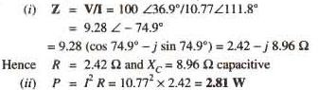V = 

Hence





1. Phase angle between voltage and current = 74.90 with current leading as shown.

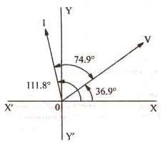

Resistance, Inductance and Capacitance in series:

The three are shown in fig. (a) Joined in series across an a.c. supply of r.m.s. voltage V

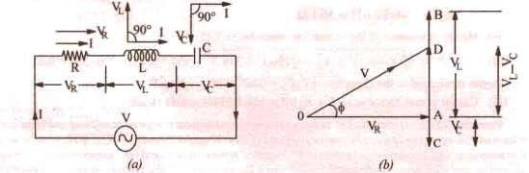

Let VR = IR = Voltage drop across R in phase with I

VL = I.XL = Voltage drop across L ---- Leading I by 

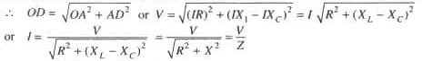VC = IXC = = Voltage drop across C ---- Lagging I by 

Then the term  is known as the impedance of the circuit. Obviously, (impedance)2 = (resistance)2 + (net reactance)2



Where X is the net reactance (fig)

Phase angel Ф is given by net reactance /resistance Power factor is



Hence, it is seen that if the equation of the applied voltage is  then equation of the resulting current in an R-L-C circuit is given by 



The positive sign is to be used when current lags i,e,

The negative sign is to be used when current lags i.e when

In general, the current lags or leads the supply voltage by an angle Ф such that

Using symbolic notation, we have  Numerical value of impedance



Its phase is 



**RESONANCE:**

Resonance occurs in electric circuits due to the presence of energy storing elements like inductor and capacitor. It is the fundamental concept based on which, the radio and TV receivers are designed in such a way that they should be able to select only the desired station frequency.

There are two types of resonances, namely series resonance and parallel resonance. These are classified based on the network elements that are connected in series or parallel. In this chapter, let us discuss about series resonance.

Series Resonance Circuit Diagram:

If the resonance occurs in series RLC circuit, then it is called as Series Resonance. Consider the following series RLC circuit, which is represented in phasor domain.

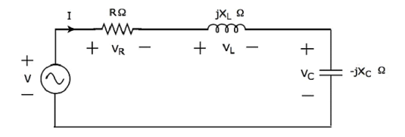

Here, the passive elements such as resistor, inductor and capacitor are connected in series. This entire combination is in series with the input sinusoidal voltage source.

Apply KVL around the loop.

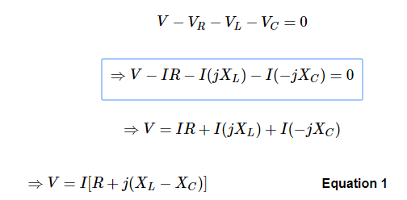

The above equation is in the form of ***V = IZ***.

Therefore, the **impedance Z** of series RLC circuit will be



## Parameters & Electrical Quantities at Resonance

Now, let us derive the values of parameters and electrical quantities at resonance of series RLC circuit one by one.

### Resonant Frequency:

The frequency at which resonance occurs is called as resonant frequency *fr*. In series RLC circuit resonance occurs, when the imaginary term of impedance *Z* is zero, i.e., the value of XL−XCshould be equal to zero.

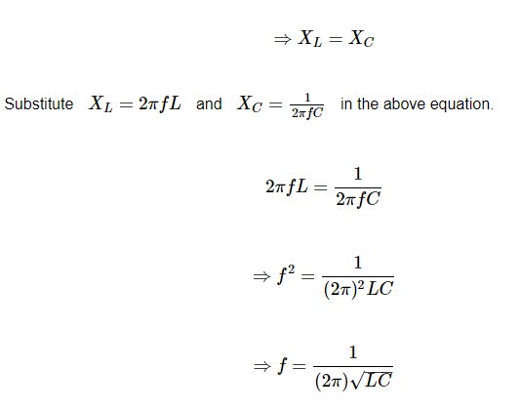

Where, *L* is the inductance of an inductor and *C* is the capacitance of a capacitor.

The resonant frequency *fr* of series RLC circuit depends only on the inductance *L* and capacitance *C*. But, it is independent of resistance *R*.

### Impedance:

We got the impedance Z of series RLC circuit as



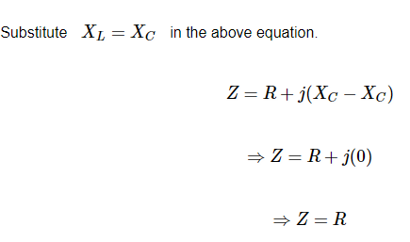

At resonance, the impedance *Z* of series RLC circuit is equal to the value of resistance *R*, i.e.,

*Z = R*.

### Current flowing through the Circuit:

XL – Xc = 0 Substitute in equation 1

V = I(R+J0)

I =V/R

At resonance, the impedance of series RLC circuit reaches to minimum value. Hence, the maximum current flows through this circuit at resonance.

**At resonance condition :**

1.minimium impedance

2.maximum current

3.power factor is unity

4.circuit will act as purely resistive circuit.